PRACTICAL – 4
Add dynamic UI components such as collapsible FAQ, modal popup, image/content slider, notification banner, hamburger menu, and light/dark theme switcher using JavaScript.

The StudentHub website developed in the previous practical contains static HTML and CSS pages. In this practical, JavaScript is used to make the website interactive and user-friendly.
The following dynamic components are implemented:
- Collapsible FAQ
- Modal popup
- Content slider
- Notification banner
- Hamburger menu
- Light/Dark theme switcher

Dark/Light Theme:
Dark Mode:
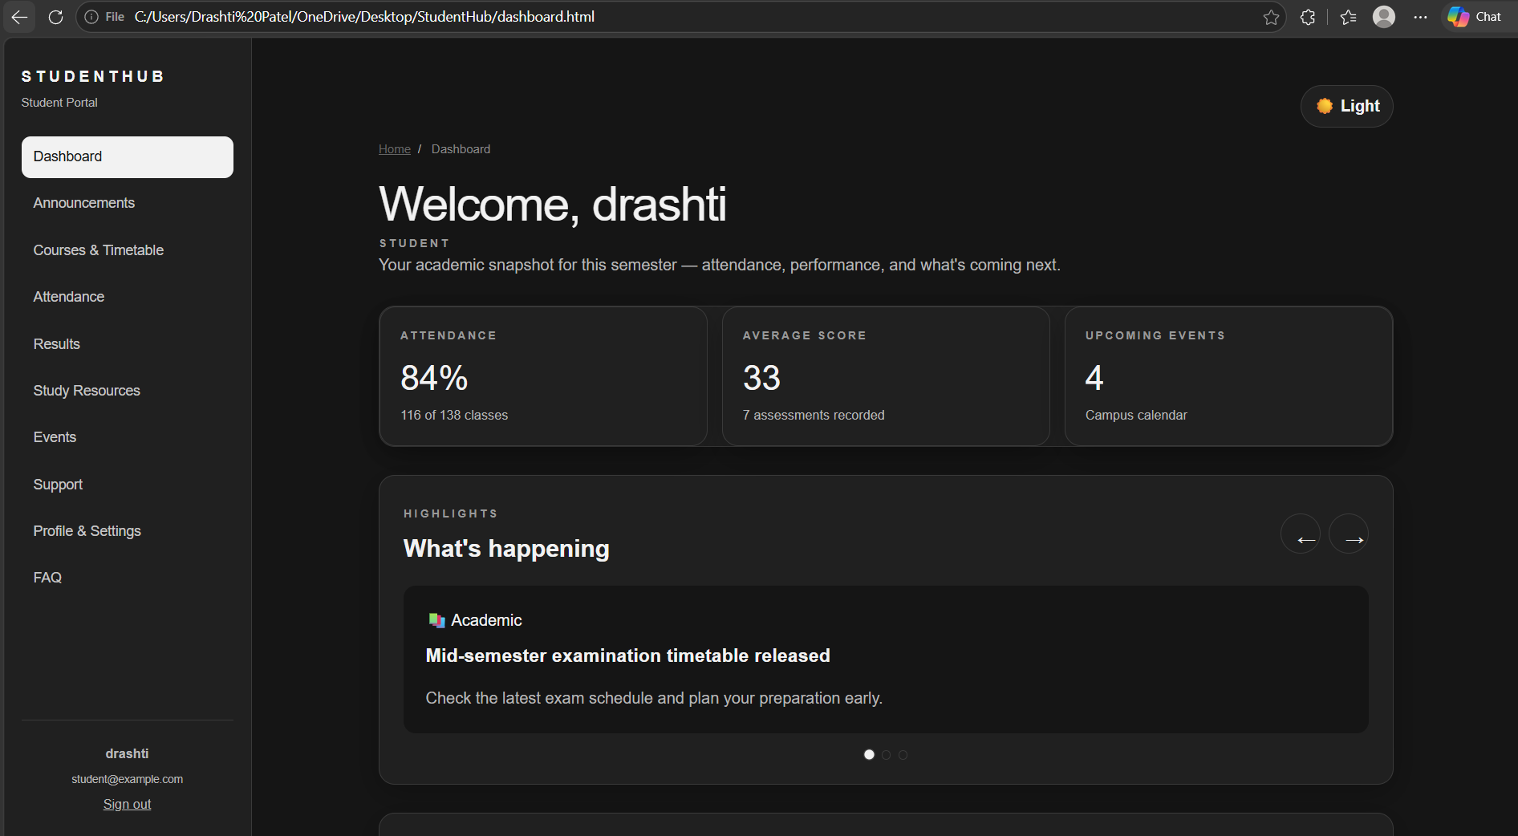

Light Mode:
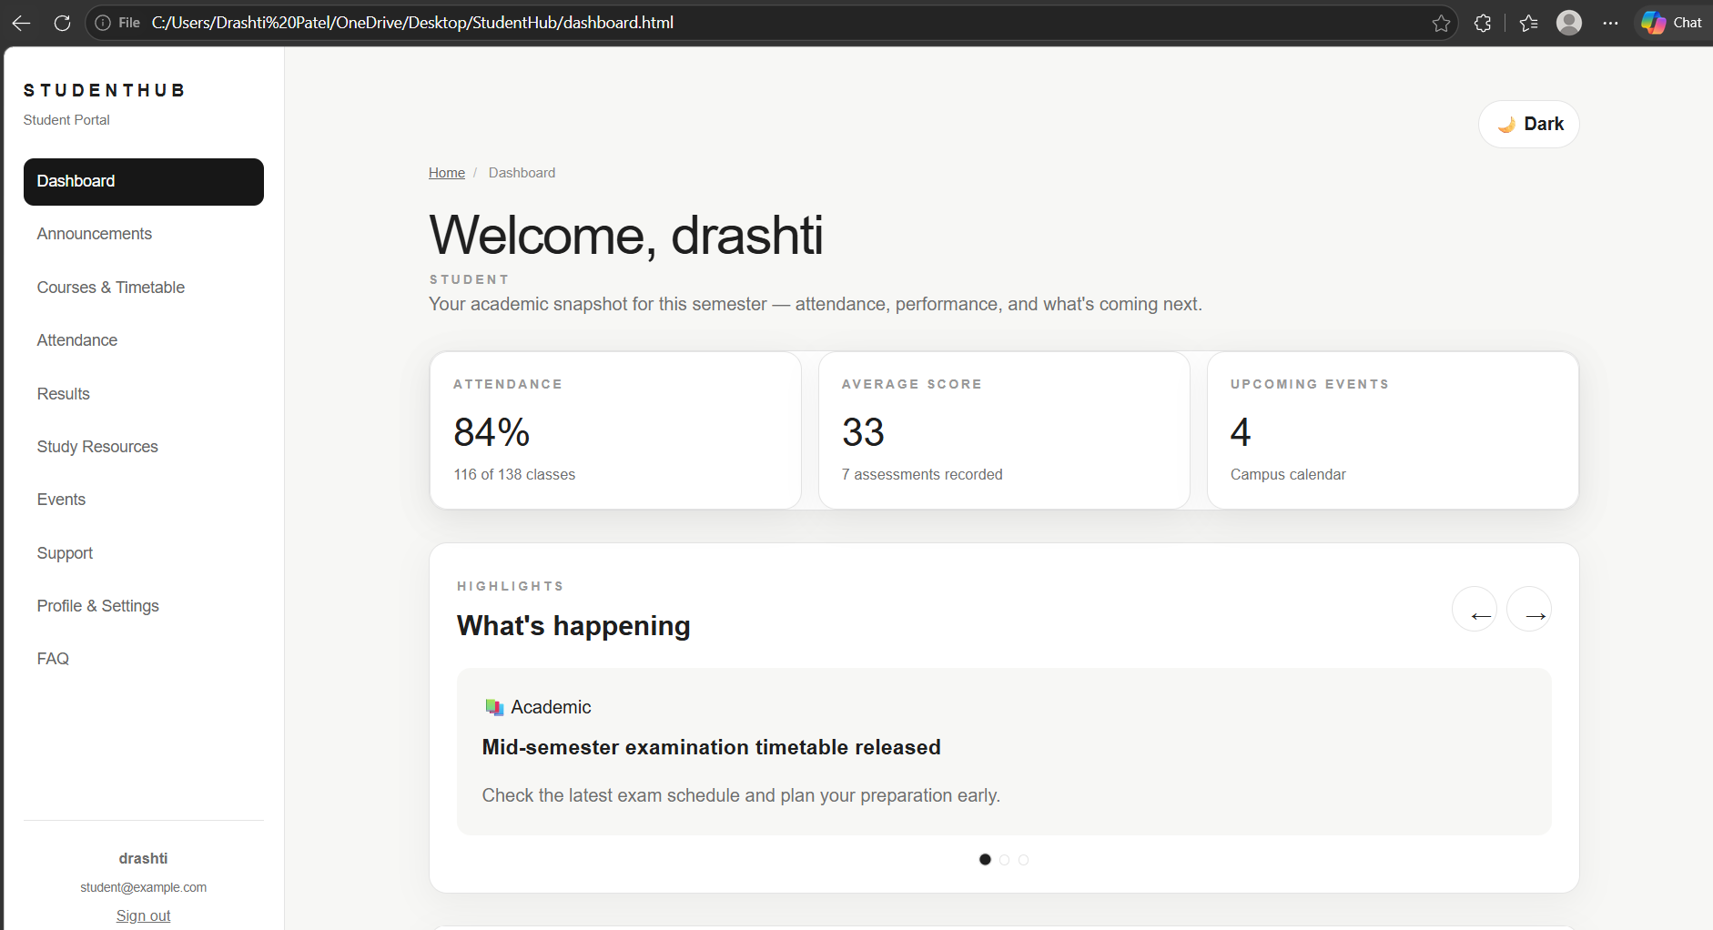

Hamburger Menu:
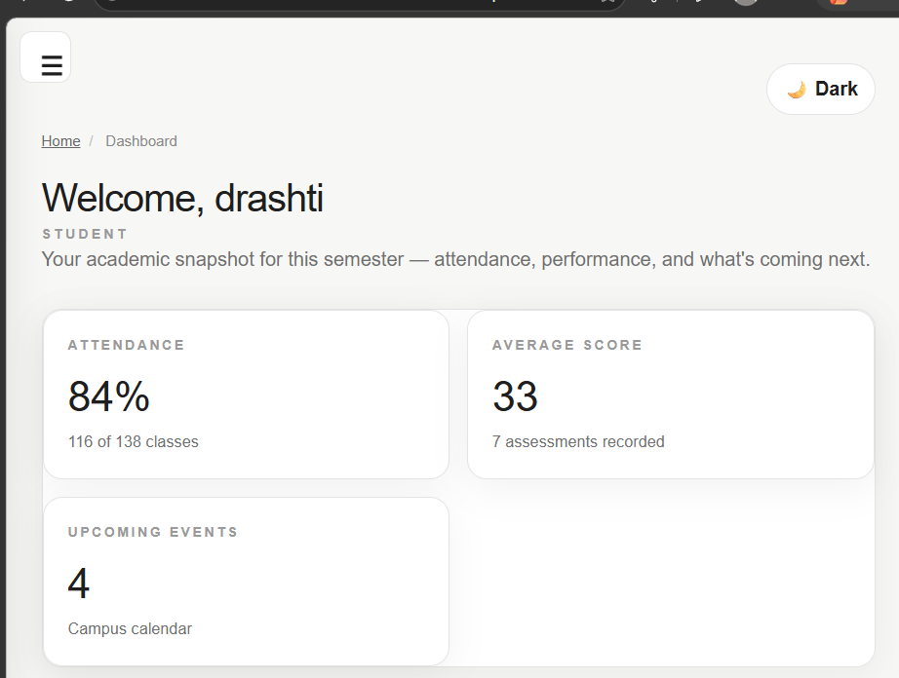

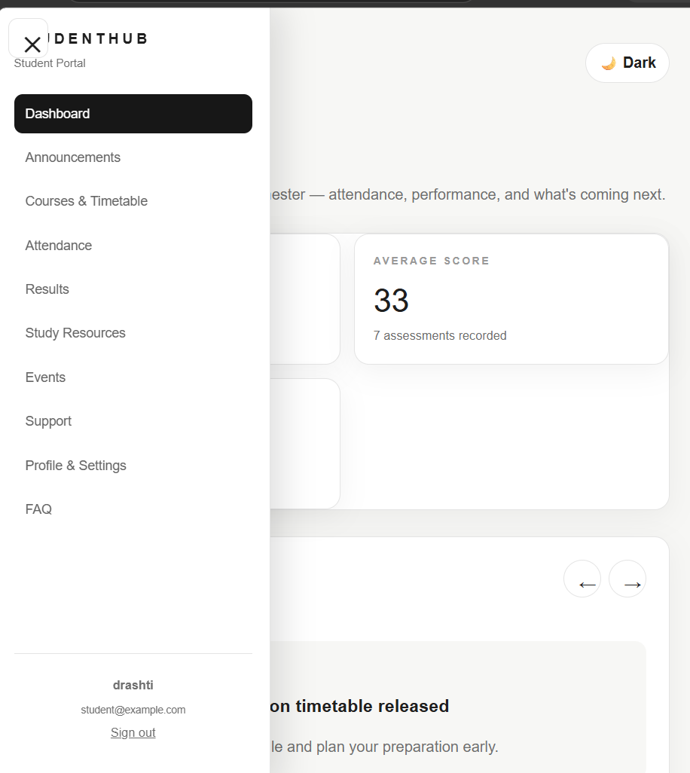

Collapsible FAQ:
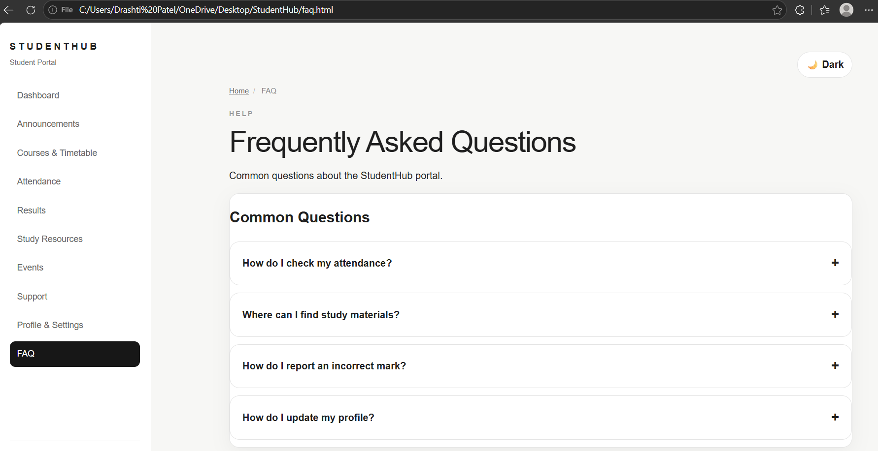

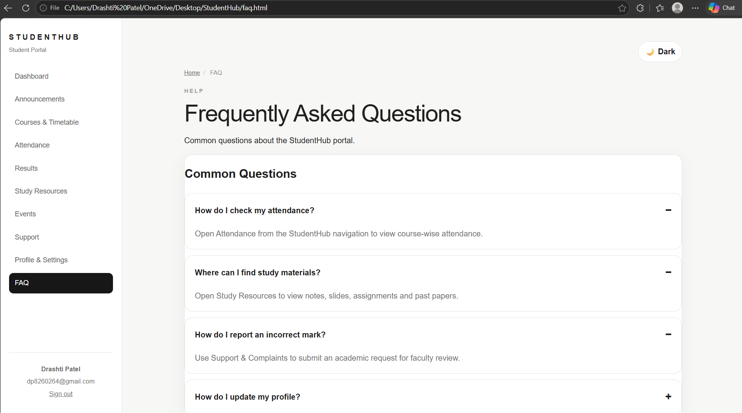

Notification banner: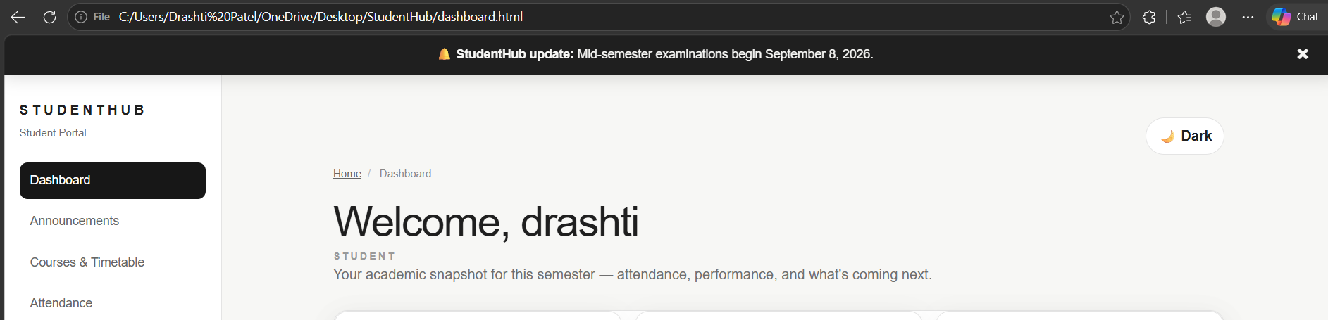

Modal Popup:
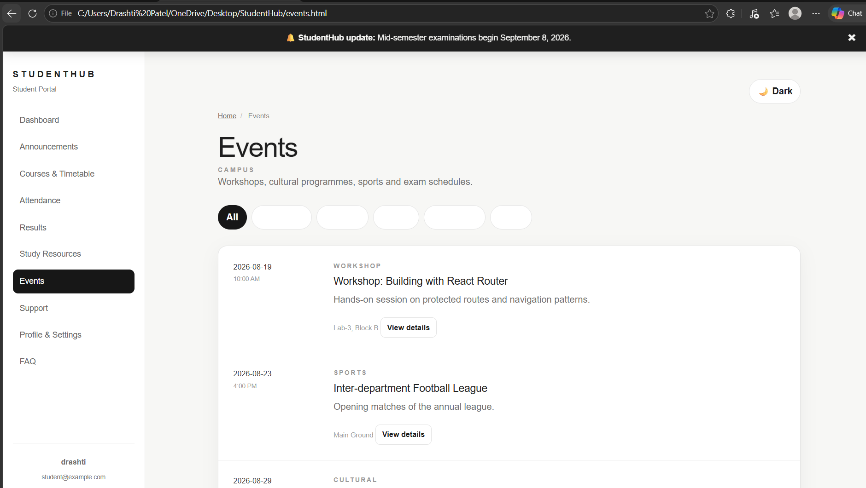
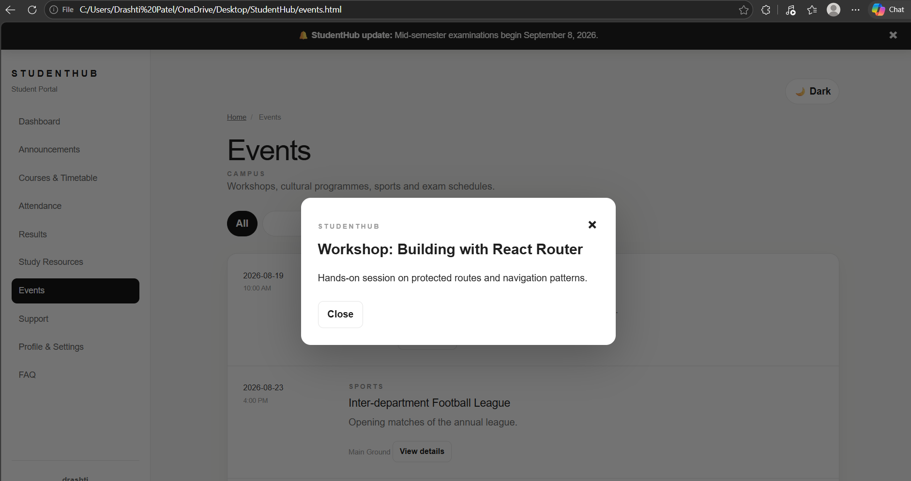

Content slider:
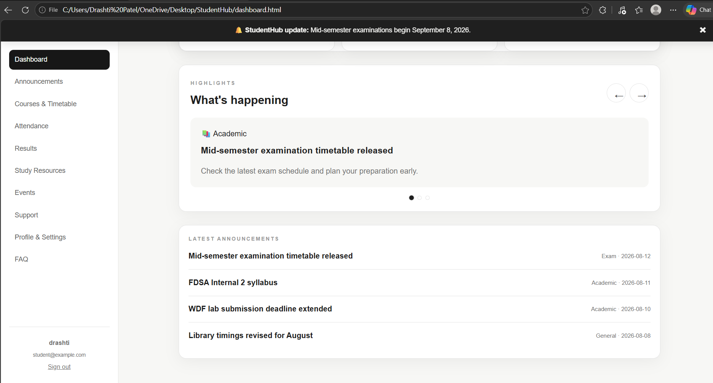

Key Questions:
1. How are DOM elements selected and modified?
Ans: DOM elements are selected using methods such as getElementById() and
querySelector(). They can be modified using properties and methods such as style,
textContent, and classList.

2. Are event listeners attached correctly?
Ans: Yes. addEventListener() is used to respond to events such as button clicks.

3. Is localStorage used for remembering the theme?
Ans: Yes. The selected theme is stored in localStorage, so it can be restored when the page is
opened again.
4. Does interactivity improve usability without breaking accessibility?
Ans: Yes. Buttons are used for interactive actions, and accessibility attributes such as labels
can be added so keyboard and assistive-technology users can understand the controls.
GitHub Link: https://github.com/dp8260264-sys/StudentHub.git

PRACTICAL – 5
Create a student registration form with HTML5 input types and JavaScript validation for name, email, mobile number, password, confirm password, course, year, gender, and terms acceptance. Use Regular Expression for validations.

Create a student registration form for the StudentHub website with proper HTML5 input types and JavaScript-based client-side validation. The form should validate all required fields, display errors near the relevant fields, check password strength, and provide an accessible and user-friendly registration experience.
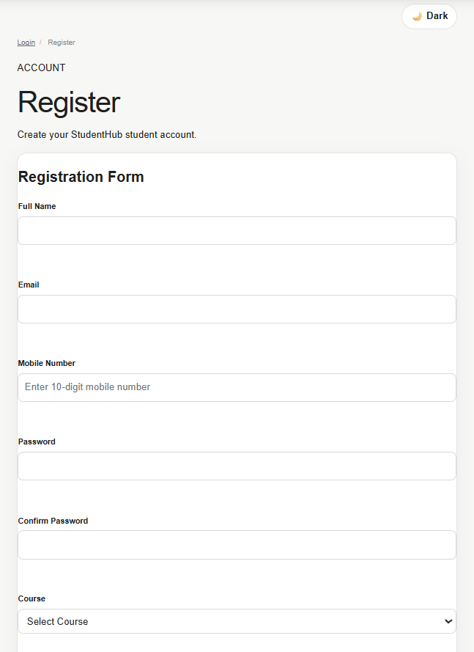
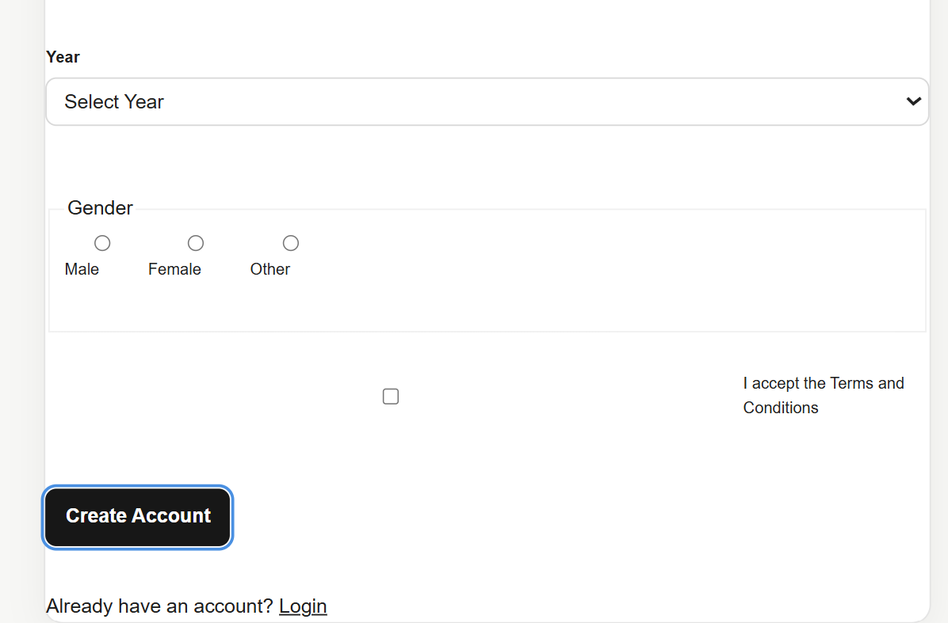

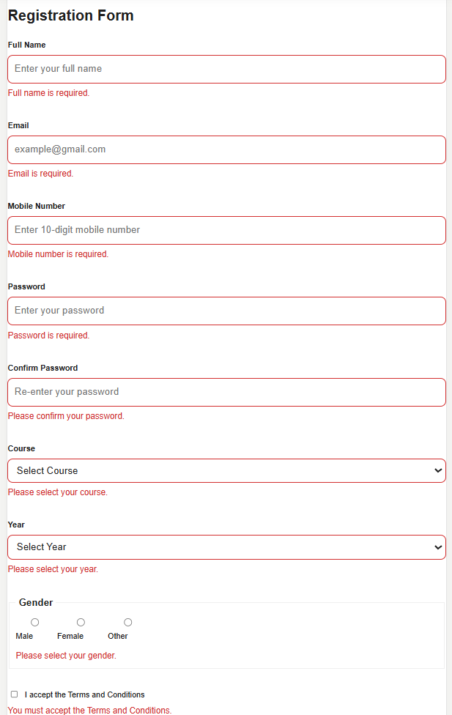

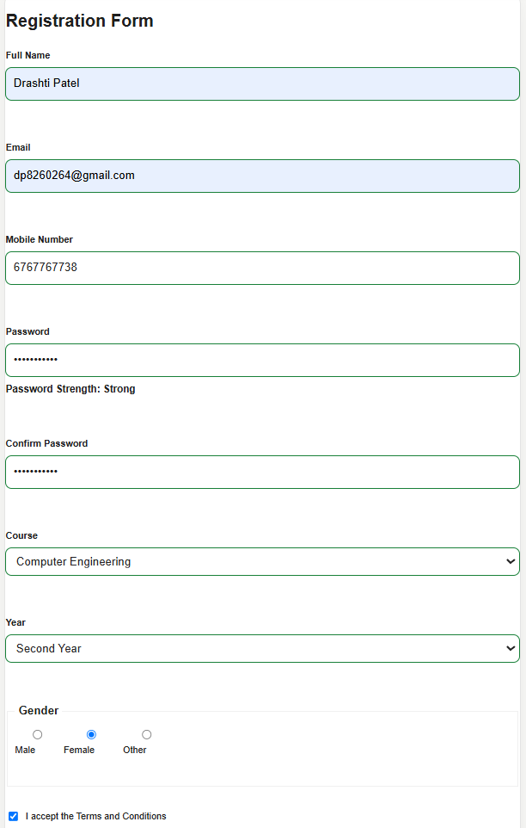

Key Questions:
1. Are correct input types and attributes used?
Ans: Yes. Appropriate HTML5 input types such as email, tel, password, radio, and checkbox
are used. Attributes such as required, autocomplete, maxlength, and aria-describedby
improve validation, usability, and accessibility.
Q2. Are validation errors displayed near the relevant fields?
Ans: Yes. Each input has a dedicated error-message area immediately below it. This makes it
easier for the user to understand and correct the problem.

3. Is password strength checked?
Ans: Yes. A password-strength indicator is provided. JavaScript checks the password length
and the presence of uppercase letters, lowercase letters, numbers, and special characters.

4. Is the form accessible using keyboard and screen-reader-friendly labels?
Ans: Yes. Every input has an associated <label>. aria-describedby and aria-live are used for
error messages, allowing screen readers to communicate validation errors to users.

GitHub Link: https://github.com/dp8260264-sys/StudentHub/blob/main/register.html

PRACTICAL – 6
Display event lists, student profiles, notices, or FAQs from external JSON files using Fetch API. Implement dynamic rendering, search, filter, sorting, and pagination.

JSON (JavaScript Object Notation) is a lightweight data format used to store and exchange structured data. In StudentHub Practical 6, JSON files are used as external data sources for information such as events, student profiles, notices, and FAQs.

The JSON data is retrieved using the JavaScript Fetch API. After fetching the file, the response is converted into a JavaScript object using the response.json() method. The data is then dynamically displayed on the webpage.

JavaScript array methods such as filter(), sort(), and slice() are used to implement searching, filtering, sorting, and pagination.

Event.html:
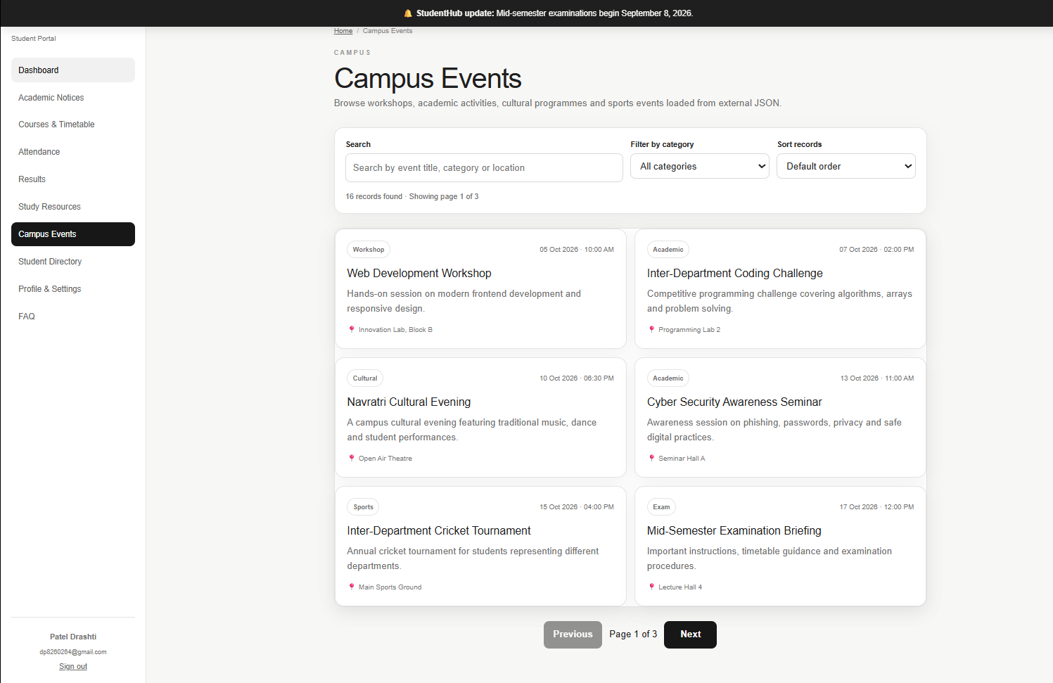



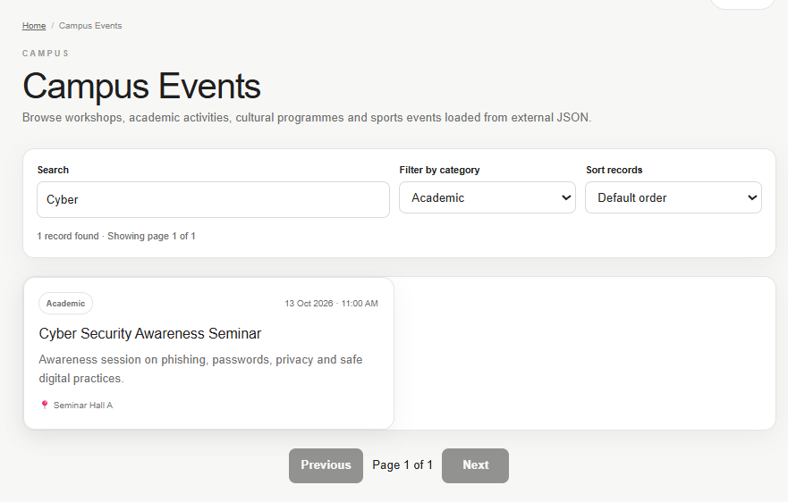

Academic notice.html:
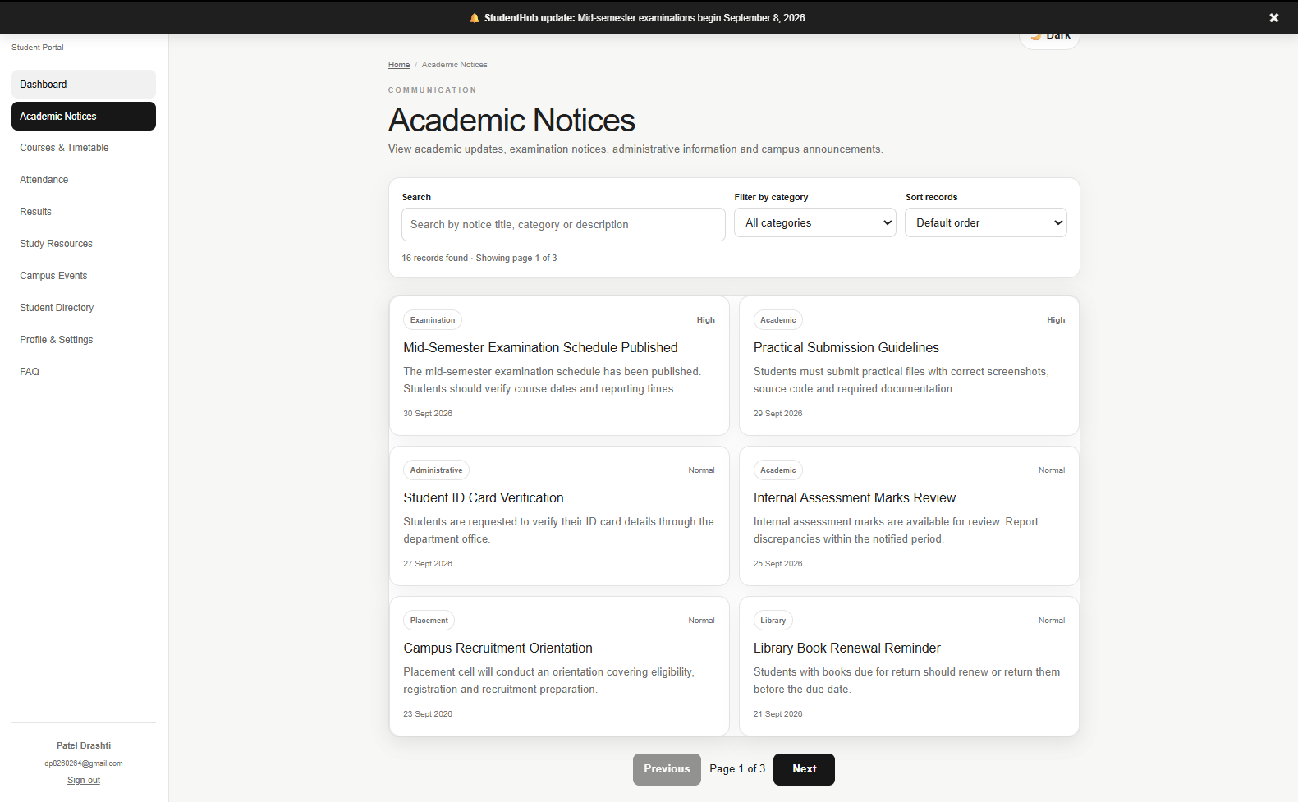

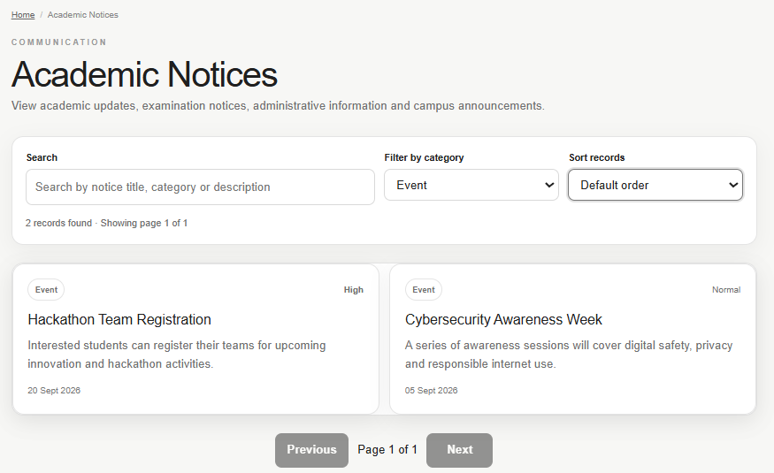

Profile.html:
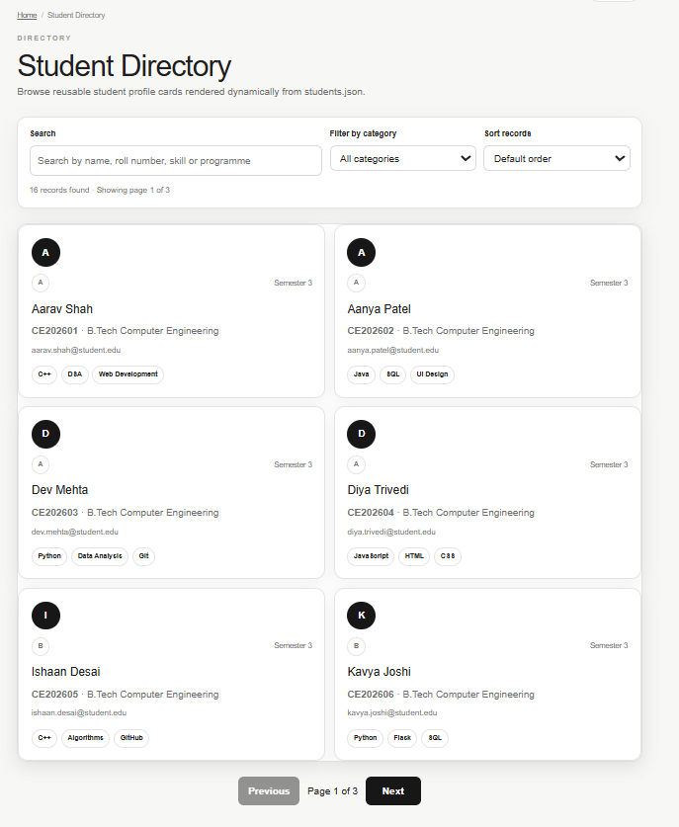

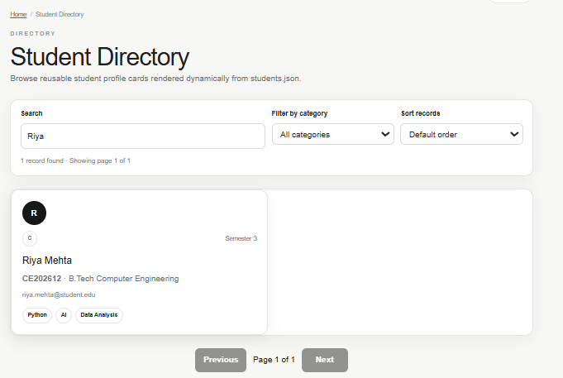

Faq.html:
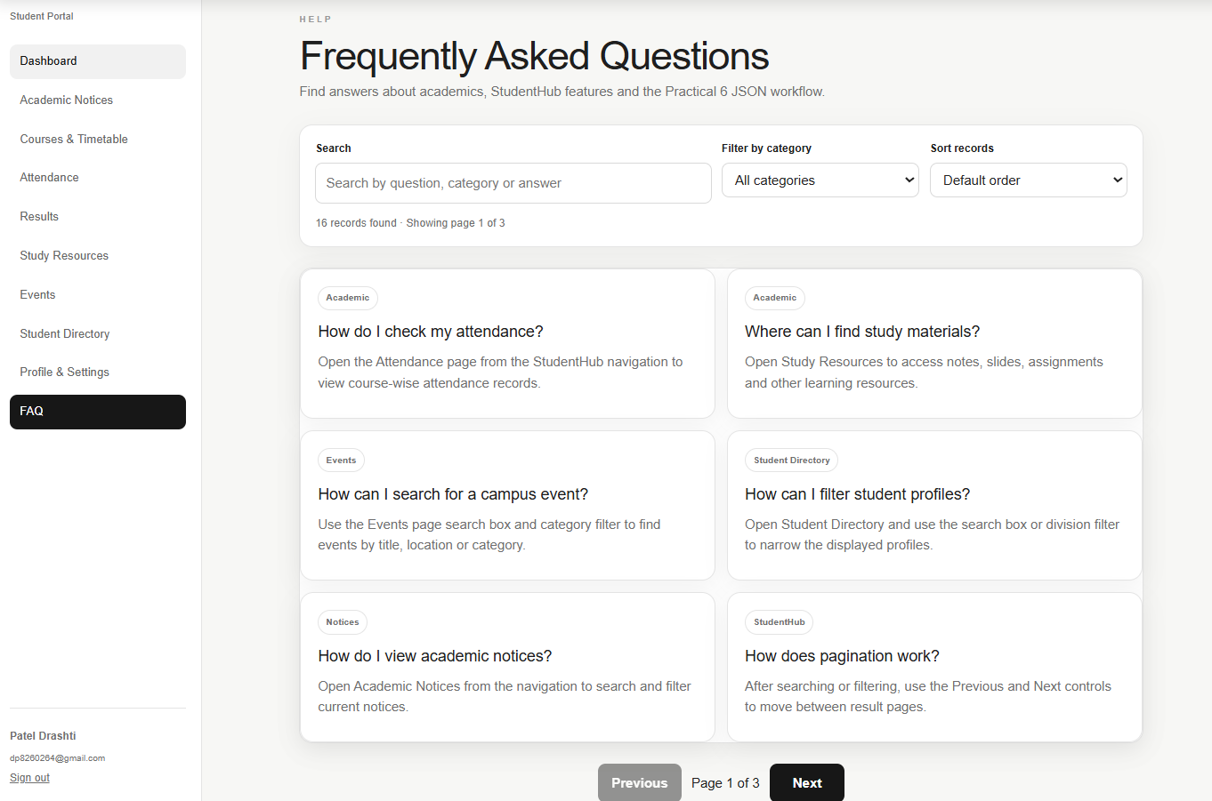

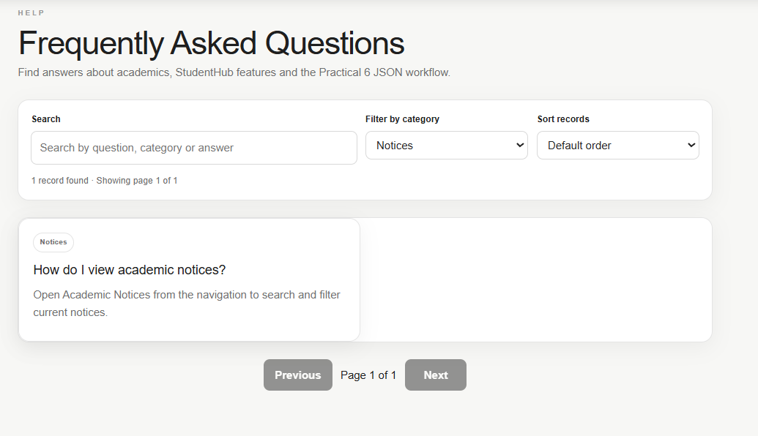

Key Questions:
1. How is JSON fetched, parsed, and rendered?
Ans: Yes. Appropriate HTML5 input types such as email, tel, password, radio, and checkbox
are used. Attributes such as required, autocomplete, maxlength, and aria-describedby
improve validation, usability, and accessibility.

Q2. Which array methods are used for search, filter, sort, and pagination?
Ans: Yes. Each input has a dedicated error-message area immediately below it. This makes it
easier for the user to understand and correct the problem.

3. How are loading and error states handled?
Ans: Yes. A password-strength indicator is provided. JavaScript checks the password length
and the presence of uppercase letters, lowercase letters, numbers, and special characters.

4. How is modularity maintained in JavaScript files?
Ans: Yes. Every input has an associated <label>. aria-describedby and aria-live are used for
error messages, allowing screen readers to communicate validation errors to users.

GitHub Link: https://github.com/dp8260264sys/StudentHub/tree/main/StudentHub/data

PRACTICAL – 7
Process submitted registration/contact form data using PHP. Validate and sanitize inputs on the server side and store records in CSV or JSON file format. Display success/error messages.

Register.php:

Code:
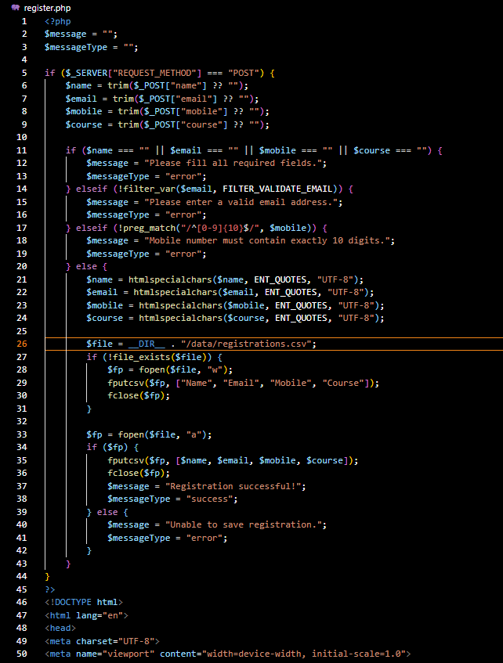

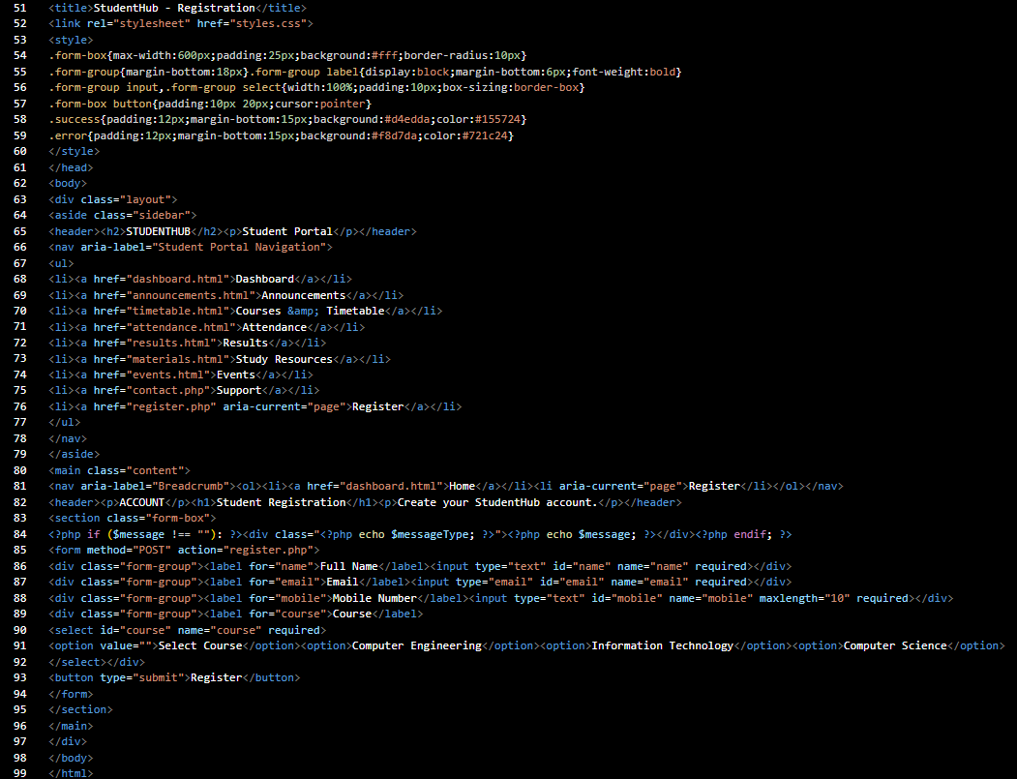

Output:
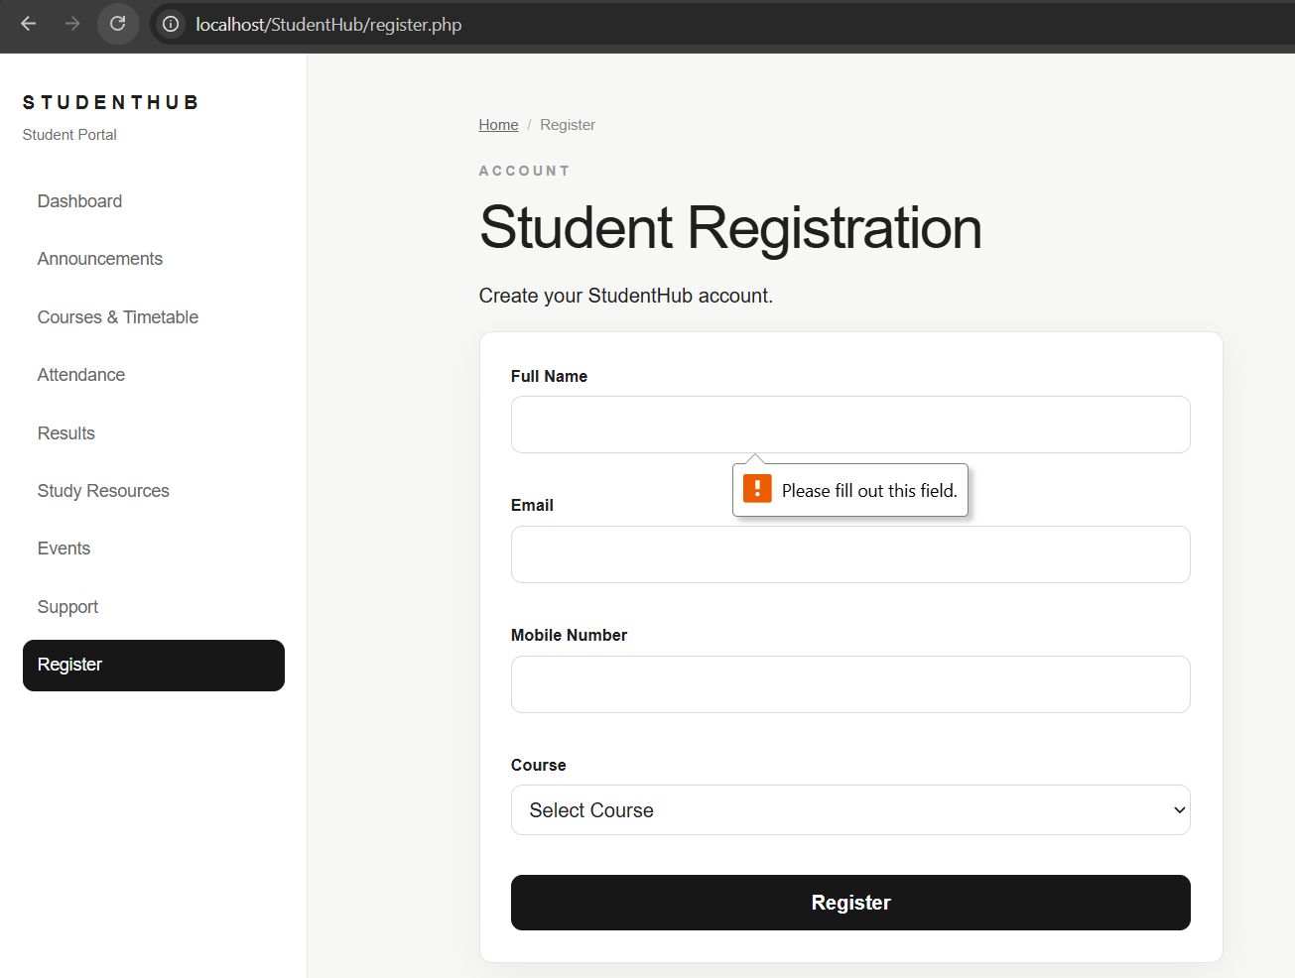
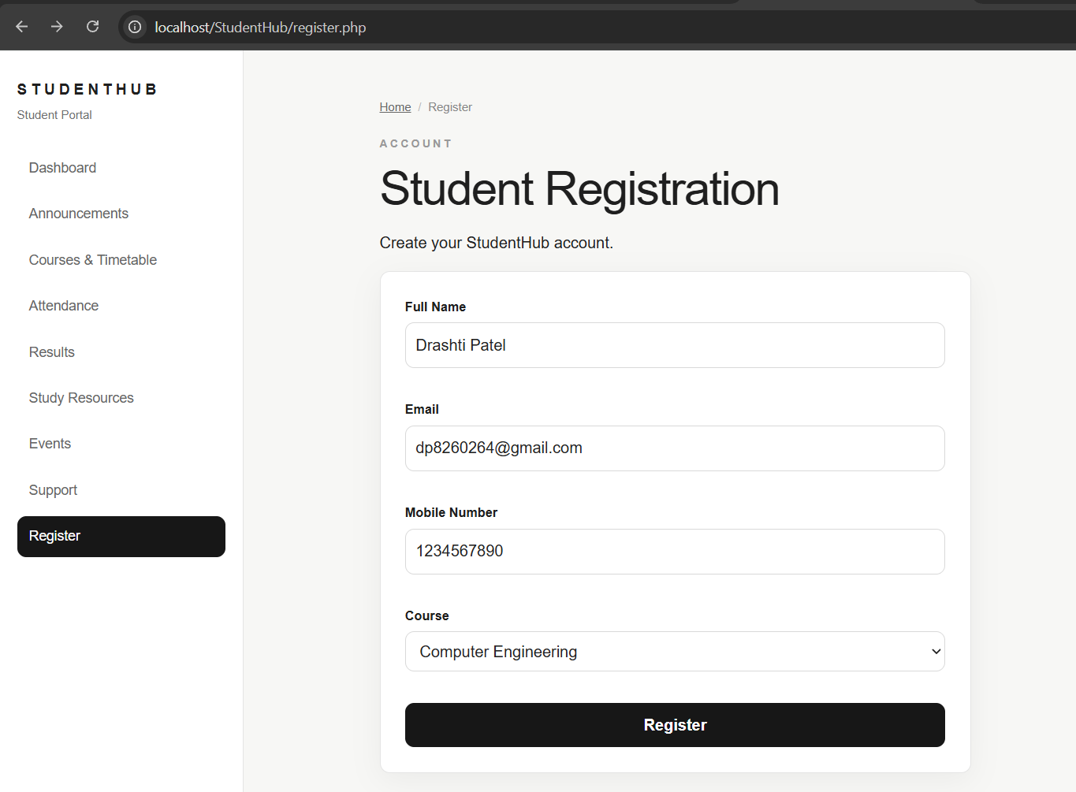

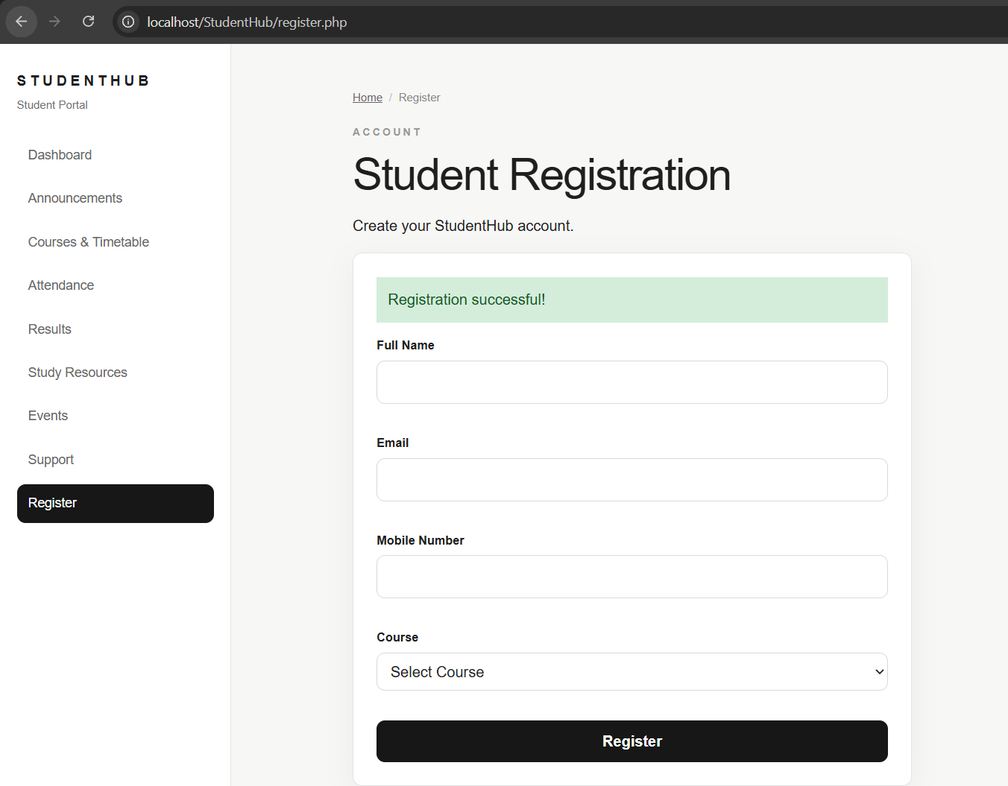
Contact.php:

Code:
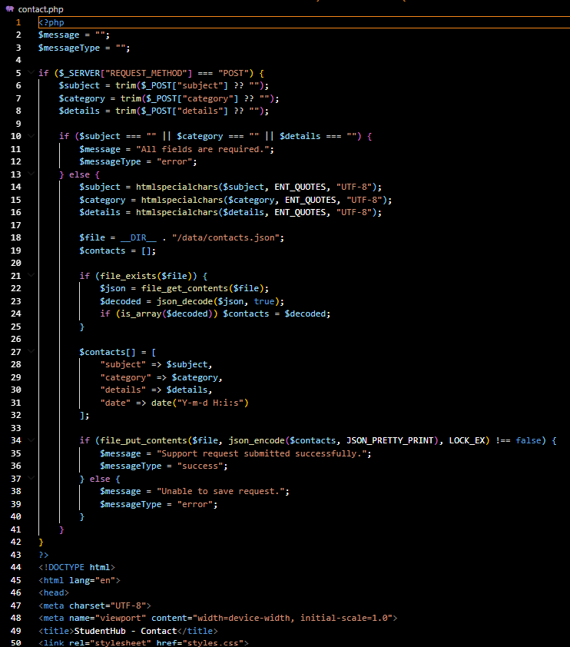

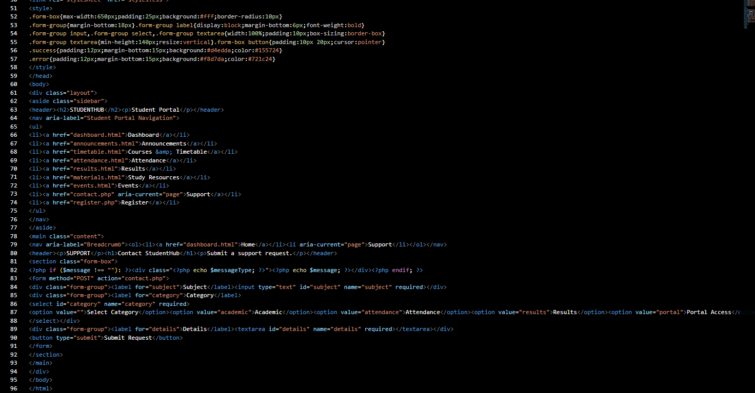

Output:
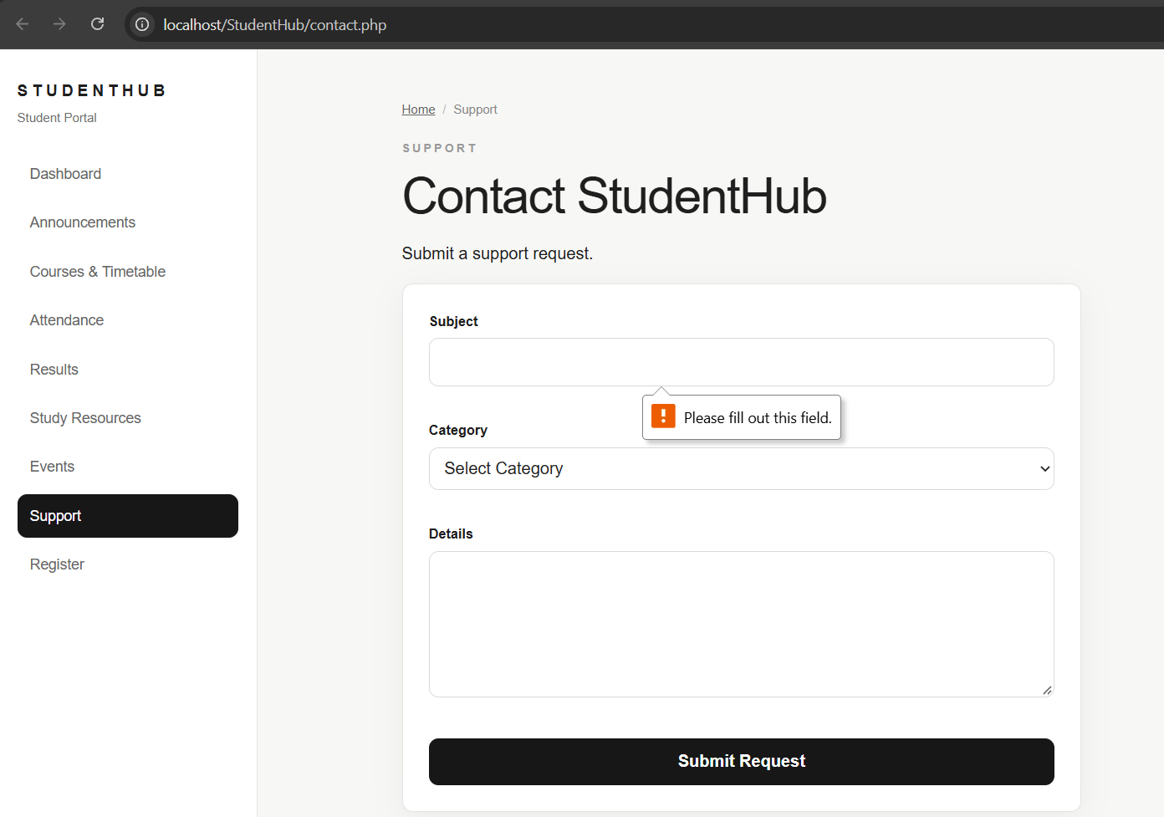

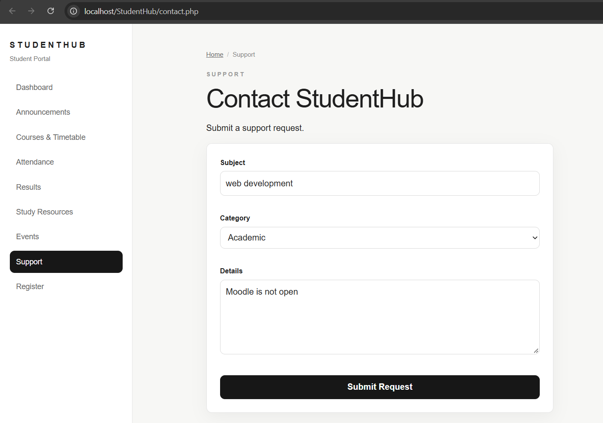

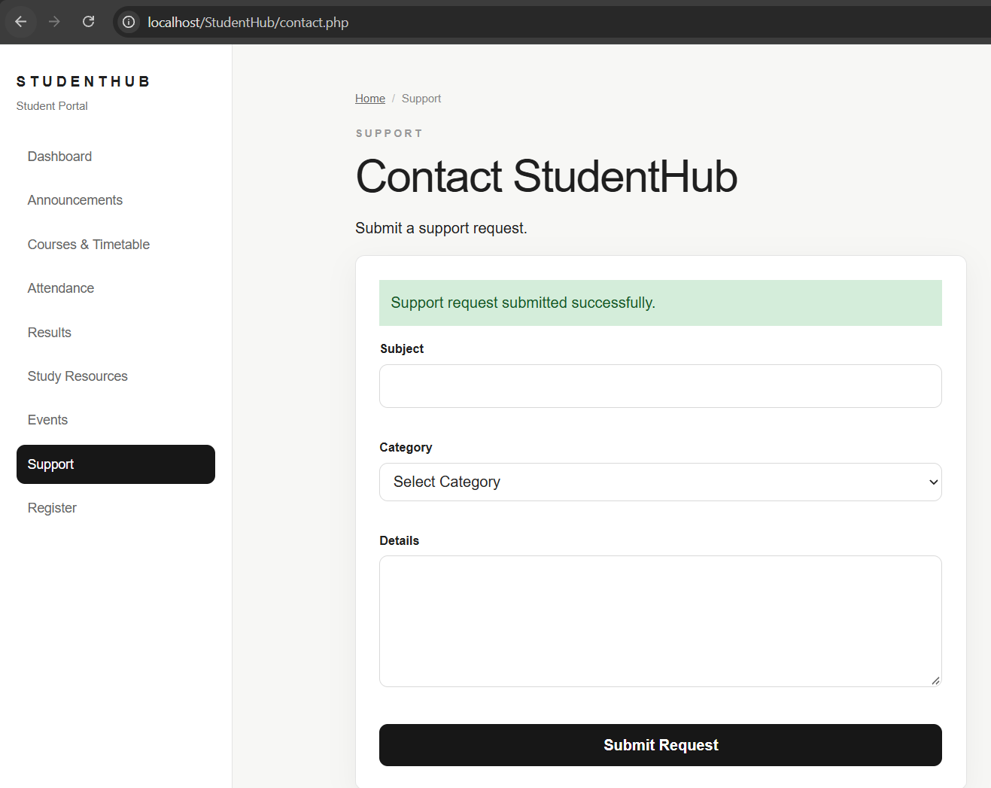
Key Questions:
1. Is the form submitted using POST?
Ans: Yes. The form is submitted using the POST method. POST sends the form data to the
PHP server without displaying the submitted values in the URL. PHP checks the request
using $_SERVER["REQUEST_METHOD"] and processes the data using $_POST.

Q2. Are inputs validated and sanitized server side?
Ans: Yes. All form inputs are validated and sanitized on the server side using PHP.
Required fields are checked, email addresses are validated using filter_var(), and
mobile numbers are checked using regular expressions. htmlspecialchars() is used to
sanitize input and reduce the risk of malicious HTML/script content.

3. Is file writing handled safely?
Ans: Yes. The submitted data is stored safely in CSV and JSON files. CSV data is written
using fputcsv(), while JSON data is stored using json_encode(). The JSON file uses
LOCK_EX during writing to reduce the chance of simultaneous write conflicts. Files
are created when they do not already exist.

4. Are success and error responses displayed clearly?
Ans: Yes. The PHP program displays clear success and error messages after form submission.
For example, a valid submission displays a success message such as "Registration
successful!", while invalid or incomplete data displays an appropriate error message
such as "Please enter a valid email address." This helps users understand whether their
submission was successful or needs correction.

GitHub Link: https://github.com/dp8260264-sys/StudentHub/tree/main/StudentHub

